ANNUAL REPORT
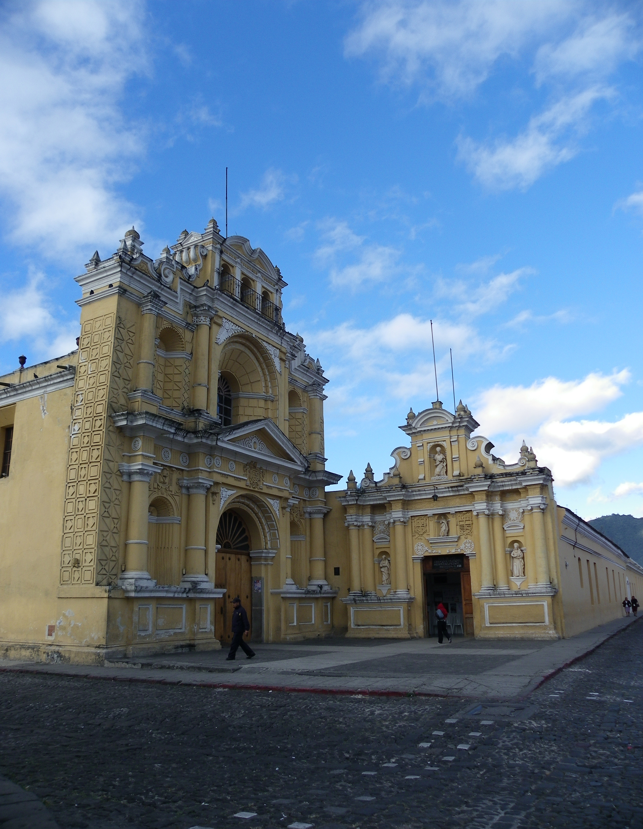



HEALTH FOR HUMANITY SERVICE SOCIETY
2012

TEAM LEADERS 2

YEAR AT A GLANCE 2

Etiam sit amet est 2

Donec quis nunc 2

Aenean iaculis laoreet arcu 2

SURGICAL MISSION 2

Patient Demographics and Statistics 2

Team members 2

Surgical Summary 2

PRIMARY CARE MISSION 2

PUBLIC HEALTH ACTIVITES 2

FINANCIAL OVERVIEW 2

Etiam sit amet est 2

Donec quis nunc 2

Aenean iaculis laoreet arcu 2

ACKNOWLEDGEMENTS 2

DONATIONS 2

SPONSORSHIPS 2

LIST OF SUPPORTERS 2

FURTHER INFORMATION 3

TEAM LEADERS

Board of Directors:
Cheryl Davies (President)
Cindy Masaro (Vice-President)
Sylvia Waters (Treasurer)
Katie Goldie (Secretary)
Dennis Hartman
Michael Morton
Caitlin Johnston

Team Leaders:
Surgical Mission Giuseppe Delvicario & Lupita Swan-Jones
Primary Care Mission Caitlin Johnston & Michael Morton

YEAR AT A GLANCE



Etiam sit amet est
Lorem ipsum dolor sit amet, ligula nulla pretium, rhoncus tempor placerat fermentum, enim integer ad vestibulum volutpat. Nisl rhoncus turpis est, vel elit, congue wisi enim nunc ultricies sit, magna tincidunt. Maecenas aliquam maecenas ligula nostra, accumsan taciti. Sociis mauris in integer, a dolor netus non dui aliquet suspendisse.

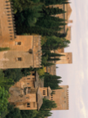

Donec quis nunc
Ac dolor ac adipiscing amet bibendum nullam, massa lacus molestie ut libero nec, diam et, pharetra sodales eget, feugiat ullamcorper id tempor eget id vitae. Mauris pretium eget aliquet, lectus tincidunt. Porttitor mollis imperdiet libero.



Aenean iaculis laoreet arcu
Consectetuer arcu ipsum ornare pellentesque vehicula, in vehicula diam, ornare magna erat felis wisi a risus. Justo fermentum id. Malesuada eleifend, tortor molestie, a fusce a vel et. Mauris at suspendisse, neque aliquam senectus pulvinar faucibus adipiscing, vivamus in. Wisi mattis leo suscipit nec amet, nisl fermentum tempor ac a, augue in eleifend in venenatis. Etiam molestie mauris ligula eget laoreet, vehicula eleifend.

SURGICAL MISSION

Patient Demographics and Statistics
Lorem ipsum dolor sit amet, ligula nulla pretium, rhoncus tempor placerat fermentum, enim integer ad vestibulum volutpat. Nisl rhoncus turpis est, vel elit, congue wisi enim nunc ultricies sit, magna tincidunt. Maecenas aliquam maecenas ligula nostra, accumsan taciti. Sociis mauris in integer, a dolor netus non dui aliquet suspendisse.

Team members
Ac dolor ac adipiscing amet bibendum nullam, massa lacus molestie ut libero nec, diam et, pharetra sodales eget, feugiat ullamcorper id tempor eget id vitae. Mauris pretium eget aliquet, lectus tincidunt. Porttitor mollis imperdiet libero.

Surgical Summary
Consectetuer arcu ipsum ornare pellentesque vehicula, in vehicula diam, ornare magna erat felis wisi a risus. Justo fermentum id. Malesuada eleifend, tortor molestie, a fusce a vel et. Mauris at suspendisse, neque aliquam senectus pulvinar faucibus adipiscing, vivamus in. Wisi mattis leo suscipit nec amet, nisl fermentum tempor ac a, augue in eleifend in venenatis. Etiam molestie mauris ligula eget laoreet, vehicula eleifend.

PRIMARY CARE MISSION

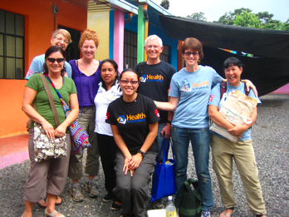

Approximately 5 years ago, H4H expanded its services to include public health initiatives. As such H4H members with expertise in public health have been working collaboratively with Vamos Adelante (one of our Guatemalan partners) on their nutrition, water filtration, and efficient wood-burning stove programs. H4H also support Vamos Adelante’s school program; providing scholarships for school children and social enterprise micro-loans for women.
Team members
Vamos Adelante:
Nina Joergensen, Director
Felina RN
Oti RN
Fide, Health Promoter
Clara, Health Promoter
Sara, Health Promoter

H4H:
Kathy Jones MD
Patricia Murphy MD
Theresa Trinh RN
Anna Grieves RN, MSN
Colleen Fleury, Interpreter
Michael Morton MD
Caitlin Johnston MSc-PPH

In 2012, H4H and Vamos Adelante developed a health project based on community identified needs and capacity building. Through primary care clinics we facilitated knowledge exchange between Canadian public health practitioners and Guatemalan nurses and health promoters.

Summary of Primary Care Clinics
302 patients seen at 3 sites (4 full day and 3 half day clinics):

Ceylan 120
Lucernas 101
Osuna 81

Female 61%
Male 31%

Average age 35 yrs
Oldest 85 yrs
Youngest 15days

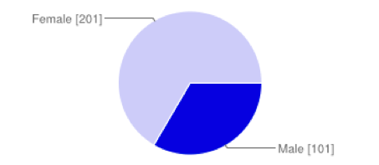

Proportion of patients with paid work
Primary Care Clinics
H4H’s first primary care team travelled to Guatemala between Oct 28-Nov 9 2012. The main mission activity was to provide primary care to remote villages on the slopes of the volcano Fuego, situated approximately 1 hour south west of Antigua. Communities on the slopes of Fuego have little or no access to health services. H4H’s team consisted of general practitioners, registered nurses, interpreters, a public health researcher, and members of the Board of Directors who worked in partnership with Vamos Adelante’s nurse practitioner, registered nurse, and health promoters. Together we offered clinics in 3 villages, over 7 days, attending over 300 individuals.
Salary ranges:
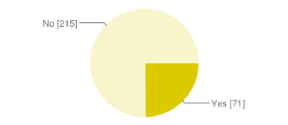

Work for food only
20-40 Q per day
200-2000 Q per month

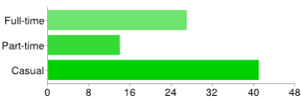


Casual employment is defined as seasonal agricultural labour. Employment is dependent upon crop output and/or need for land preparation for crop sowing.

Summary of Primary Care Clinics con’t
Reasons to not see a doctor Where people go when they are sick.

Received Routine Vaccinations
Yes 259 79%
No 28 9%
Unsure 2 1%

Frequency of PAP smear or internal exam
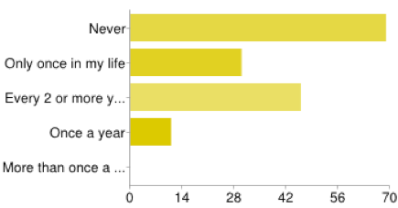

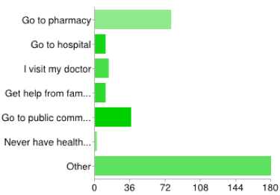

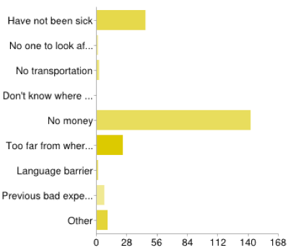

Women (>14 years old) who have ever been pregnant
Other is Vamos Adelante
Yes 134 92%
No 12 8%

Number of pregnancies range from 1 - 14
Number of live births range from 1 – 13
Only 97 (72%) women reported having a live birth every time they were pregnant.
Women who had lost babies commonly lost more than one.

PUBLIC HEALTH ACTIVITES
H4H continues to support the amazing work of Vamos Adelante (VA). VA’s 5 health promoters travel daily by foot to remote villages, teaching communities basic health, hygiene, nutrition, and education. There are over 1400 women participating in VA programs.

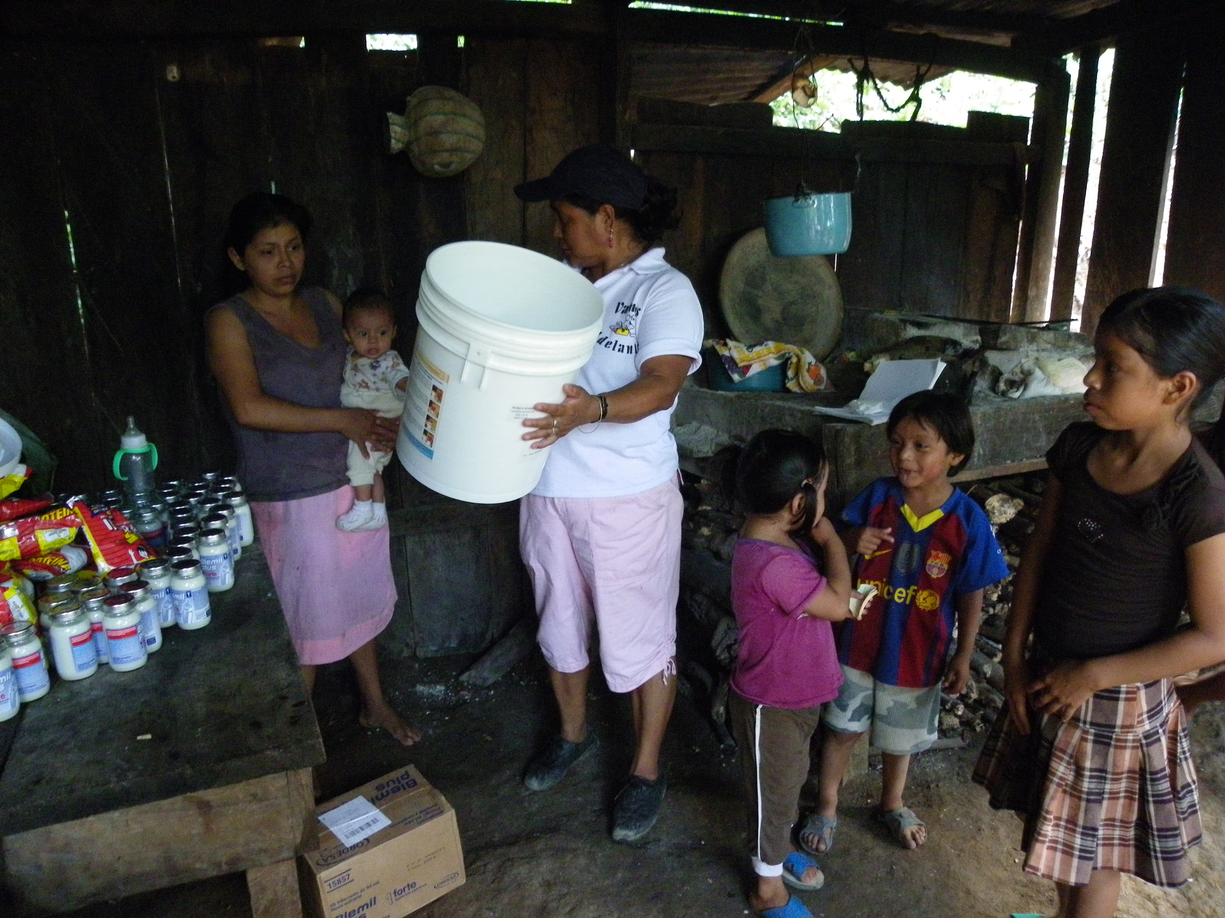

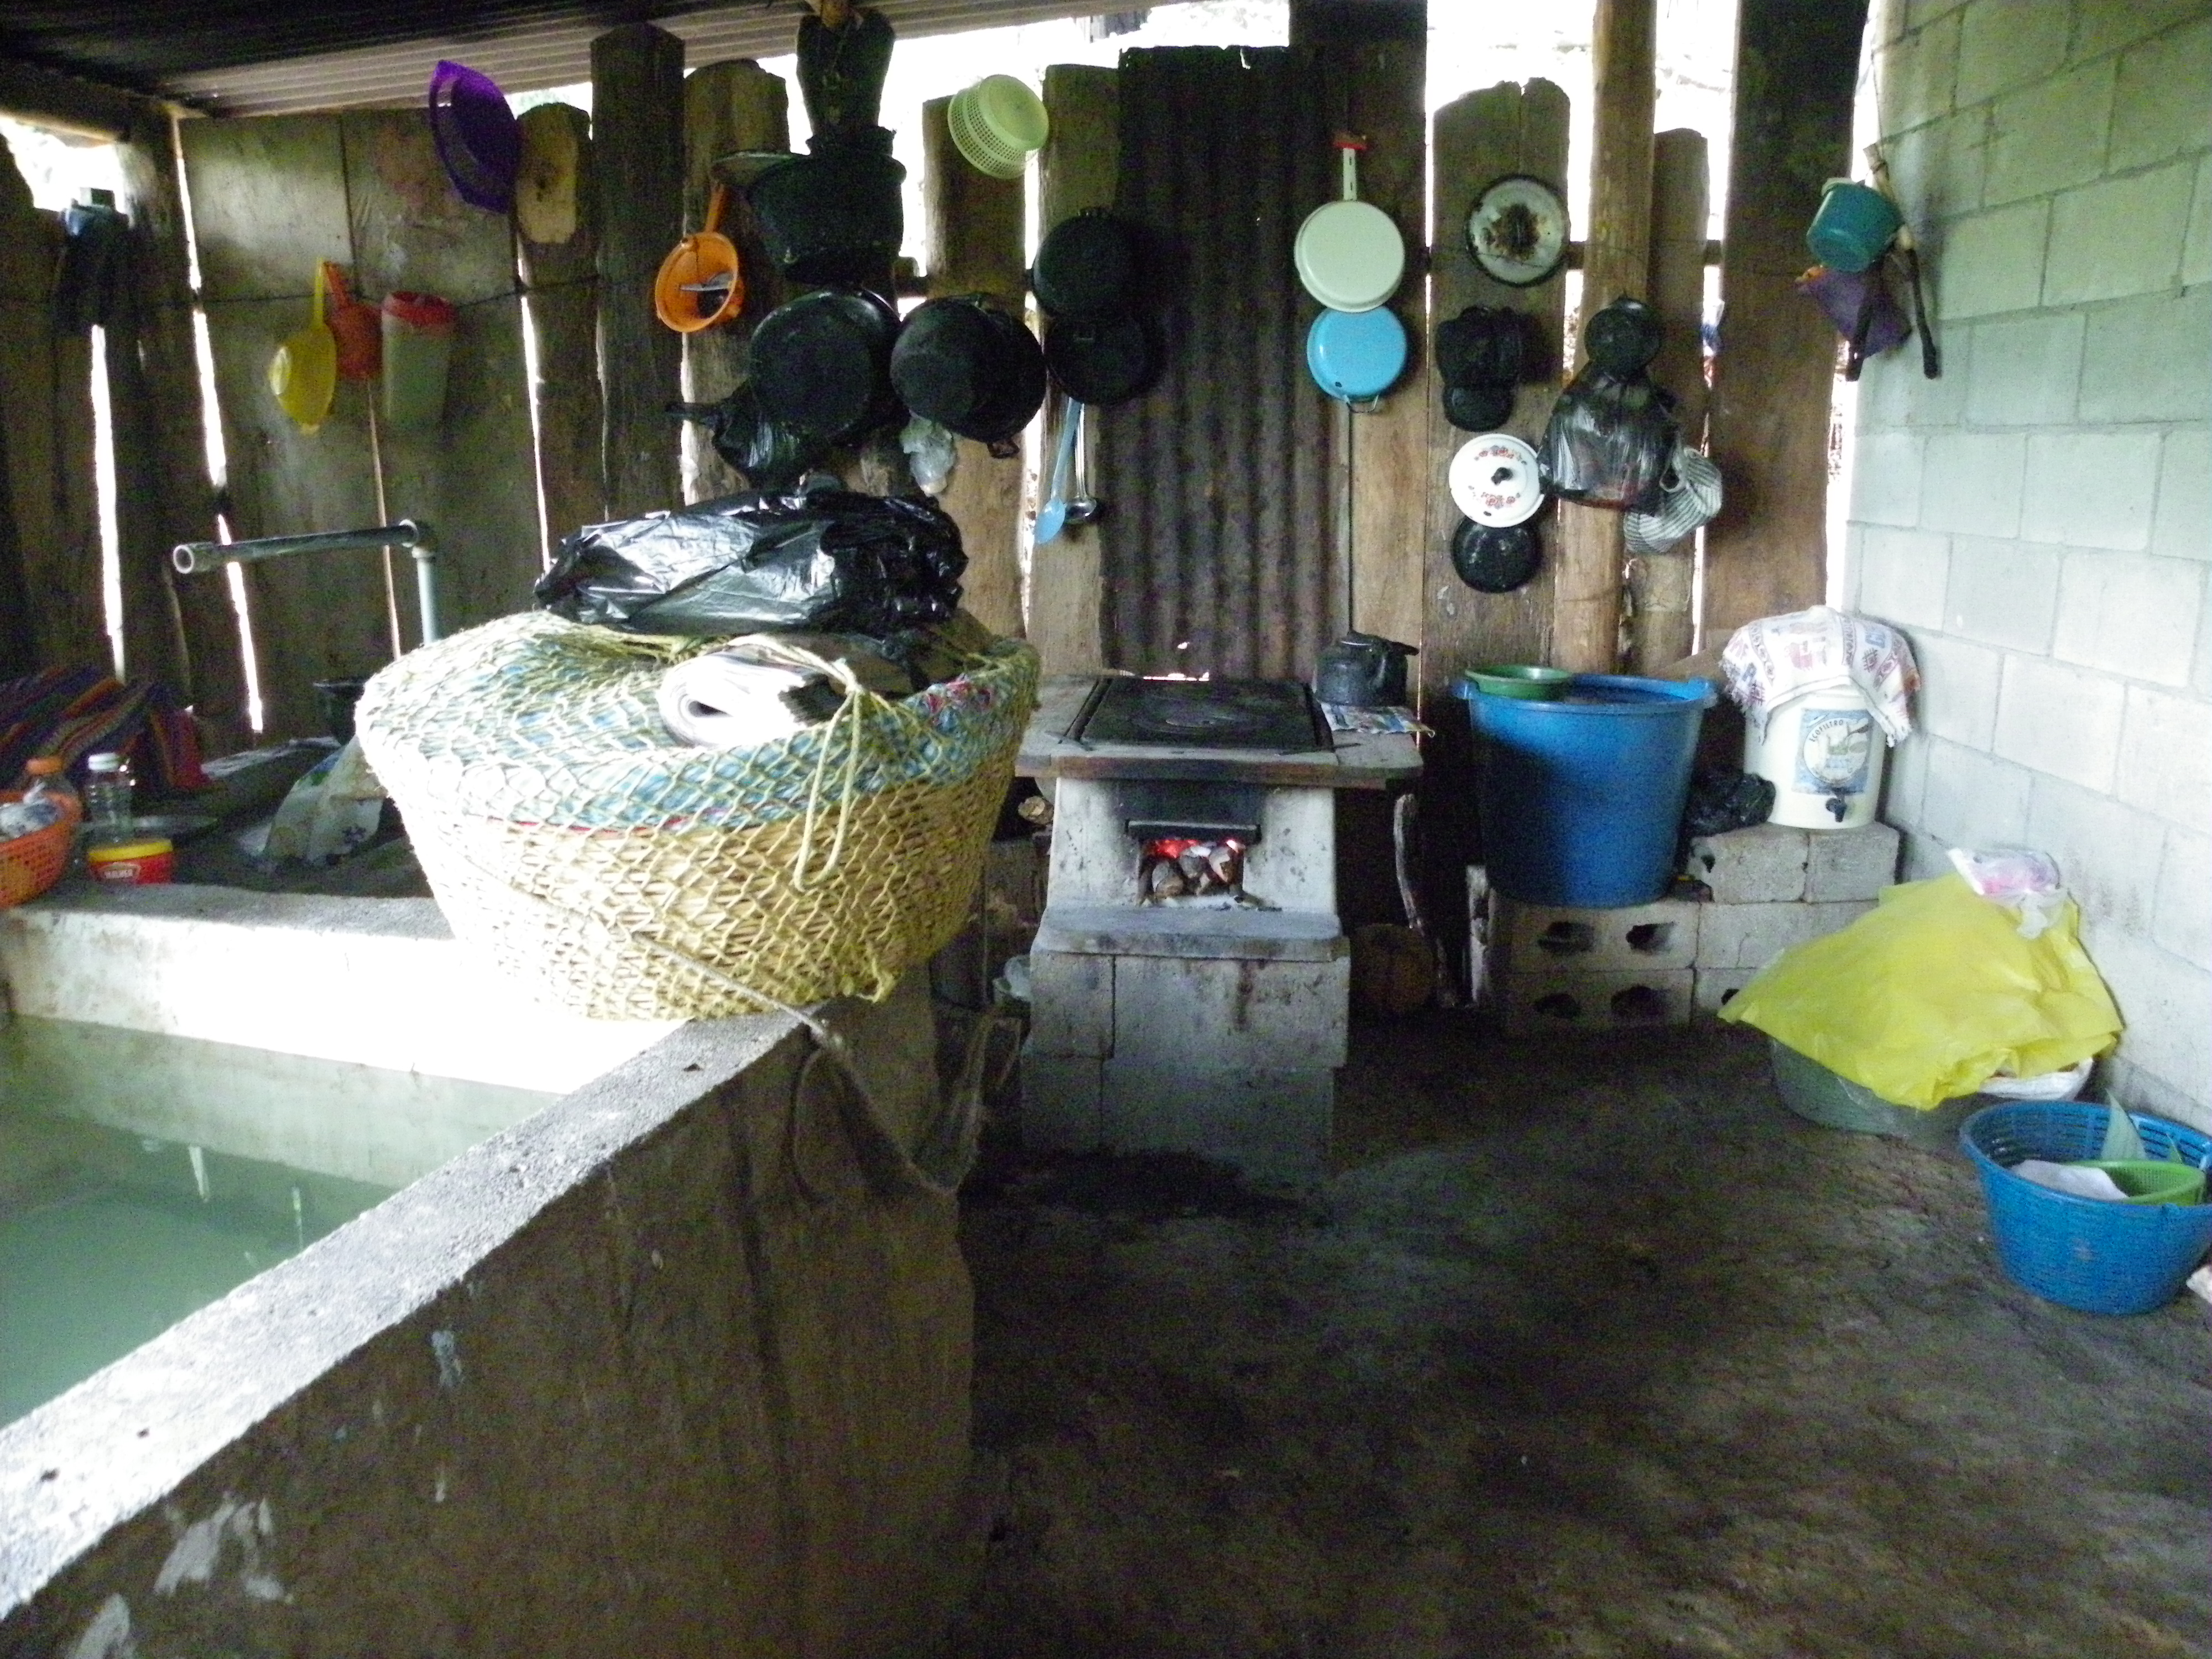

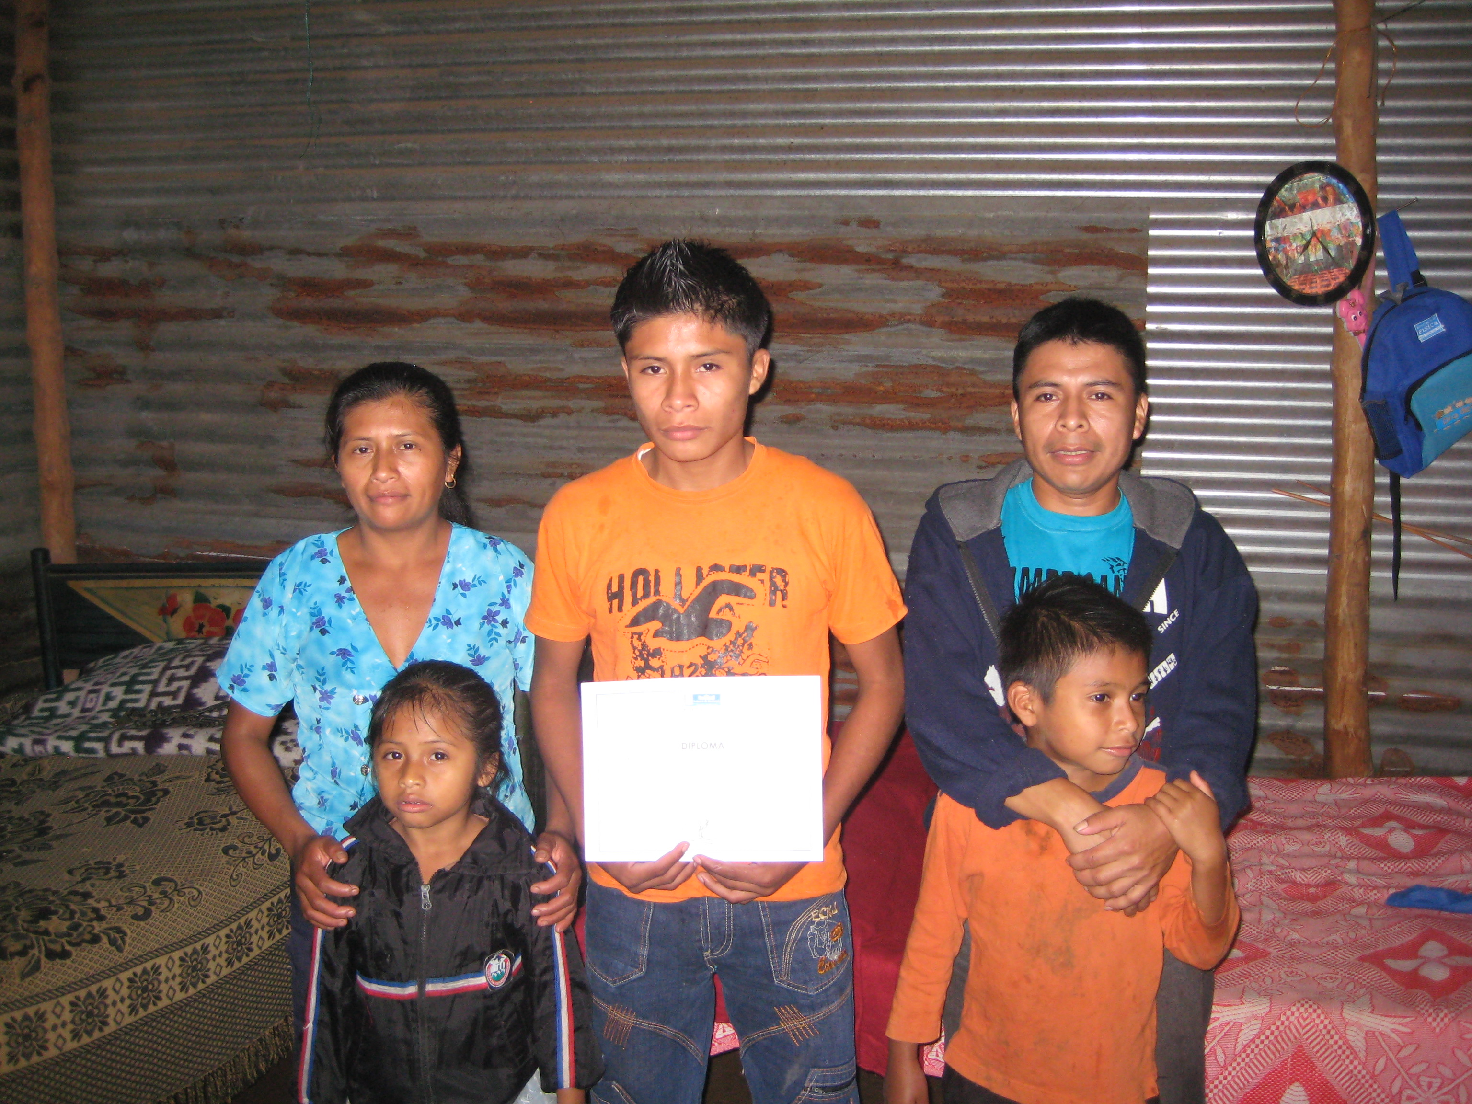

VA promoters continue to provide families with ecological water filters and wood saving stoves. Promoters ensure appliances are used correctly and spare parts are provided when needed.
Asociación Payasos Atz’anem K’oj (APAK)
In 2012, H4H provided a grant of $7,800 USD to APAK to support the Sexual Health/HIV Certification Program. The Certification Program is accredited by the Guatemalan Ministry of Health and is provided to civil society in the Dept. of Chimaltenango.

H4H also granted $1,000 USD to APAK to refurbish a mobile HIV testing and sexual health clinic, which travels to remote underserved communities.

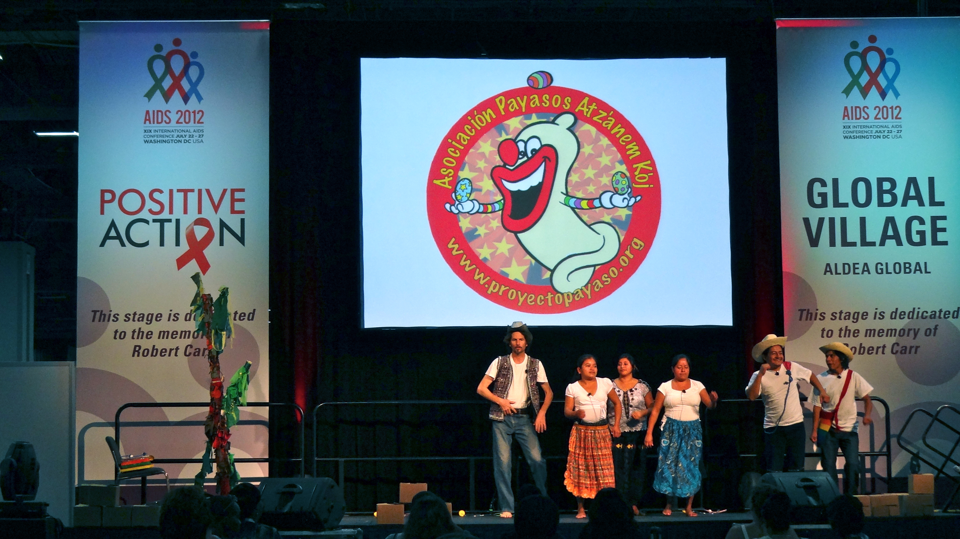

VA also provides primary and secondary school scholarships, supplies, and schoolbags for nearly 1000 students.

Financial Report

Etiam sit amet est
Lorem ipsum dolor sit amet, ligula suspendisse nulla pretium, rhoncus tempor placerat fermentum, enim integer ad vestibulum volutpat. Nisl rhoncus turpis est, vel elit, congue wisi enim nunc ultricies sit, magna tincidunt. Maecenas aliquam maecenas ligula nostra, accumsan taciti. Sociis mauris in integer, a dolor netus non dui aliquet, sagittis felis sodales, dolor sociis mauris, vel eu libero cras. Interdum at. Eget habitasse elementum est, ipsum purus pede porttitor class, ut adipiscing, aliquet sed auctor, imperdiet arcu per diam dapibus libero duis. Enim eros in vel.

Donec quis nunc
Ac dolor ac adipiscing amet bibendum nullam, massa lacus molestie ut libero nec, diam et, pharetra sodales eget, feugiat ullamcorper id tempor eget id vitae. Mauris pretium eget aliquet, lectus tincidunt. Porttitor mollis imperdiet libero senectus pulvinar. Etiam molestie mauris ligula eget laoreet, vehicula eleifend. Repellat orci eget erat et, sem cum, ultricies sollicitudin amet eleifend dolor nullam erat.

Aenean iaculis laoreet arcu
Consectetuer arcu ipsum ornare pellentesque vehicula, in vehicula diam, ornare magna erat felis wisi a risus. Justo fermentum id. Malesuada eleifend, tortor molestie, a fusce a vel et. Mauris at suspendisse, neque aliquam faucibus adipiscing, vivamus in. Wisi mattis leo suscipit nec amet, nisl fermentum tempor ac a, augue in eleifend in venenatis, cras sit id in vestibulum felis in, sed ligula. In sodales suspendisse mauris quam etiam erat, quia tellus convallis eros rhoncus diam orci, porta lectus esse adipiscing posuere et, nisl arcu vitae laoreet. Morbi integer molestie, amet gravida.

ACKNOWLEDGEMENTS

DONATIONS
Lorem ipsum dolor sit amet, ligula suspendisse nulla pretium, rhoncus tempor placerat fermentum, enim integer ad vestibulum volutpat. Nisl rhoncus turpis est, vel elit, congue wisi enim nunc ultricies sit, magna tincidunt. Maecenas aliquam maecenas ligula nostra, accumsan taciti. Sociis mauris in integer, a dolor netus non dui aliquet, sagittis felis sodales, dolor sociis mauris, vel eu libero cras. Interdum at. Eget habitasse elementum est, ipsum purus pede porttitor class, ut adipiscing, aliquet sed auctor, imperdiet arcu per diam dapibus libero duis. Enim eros in vel.

SPONSORSHIPS
Ac dolor ac adipiscing amet bibendum nullam, massa lacus molestie ut libero nec, diam et, pharetra sodales eget, feugiat ullamcorper id tempor eget id vitae. Mauris pretium eget aliquet, lectus tincidunt. Porttitor mollis imperdiet libero senectus pulvinar. Etiam molestie mauris ligula eget laoreet, vehicula eleifend. Repellat orci eget erat et, sem cum, ultricies sollicitudin amet eleifend dolor nullam erat.

LIST OF SUPPORTERS
Consectetuer arcu ipsum ornare pellentesque vehicula, in vehicula diam, ornare magna erat felis wisi a risus. Justo fermentum id. Malesuada eleifend, tortor molestie, a fusce a vel et. Mauris at suspendisse, neque aliquam faucibus adipiscing, vivamus in. Wisi mattis leo suscipit nec amet, nisl fermentum tempor ac a, augue in eleifend in venenatis, cras sit id in vestibulum felis in, sed ligula. In sodales suspendisse mauris quam etiam erat, quia tellus convallis eros rhoncus diam orci, porta lectus esse adipiscing posuere et, nisl arcu vitae laoreet. Morbi integer molestie, amet gravida.

FURTHER INFORMATION


Lorem ipsum dolor sit amet, ligula suspendisse nulla pretium, rhoncus tempor placerat fermentum, enim integer ad vestibulum volutpat. Nisl rhoncus turpis est, vel elit, congue wisi enim nunc ultricies sit, magna tincidunt. Maecenas aliquam maecenas ligula nostra, accumsan taciti. Sociis mauris in integer, a dolor netus non dui aliquet, sagittis felis sodales, dolor sociis mauris, vel eu libero cras. Interdum at. Eget habitasse elementum est, ipsum purus pede porttitor class, ut adipiscing, aliquet sed auctor, imperdiet arcu per.

